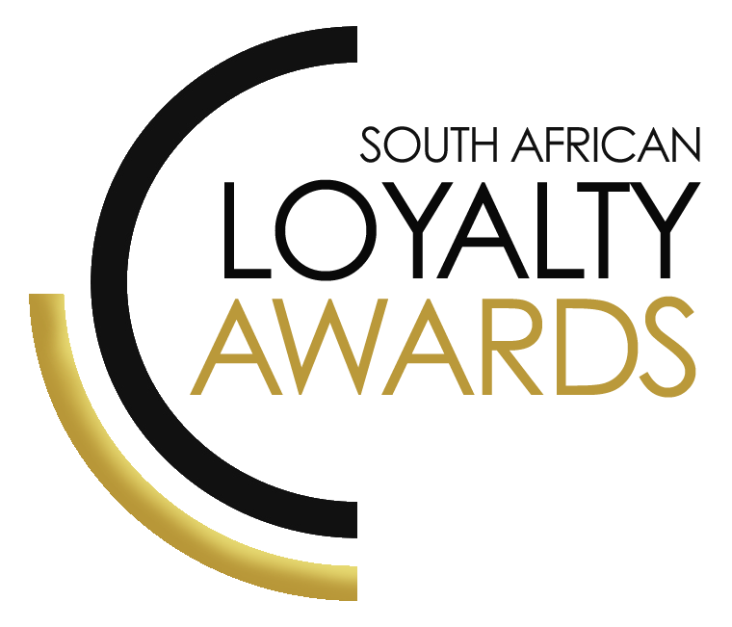
CATEGORY 2
BEST PROGRAMME OF
THE YEAR: FINANCIAL SERVICES
ENTRY FORM

ENTRY CONTACT INFORMATION:
Company name:
Contact name:
Job title:
Business email:
Telephone number:
Company logo: Transparent background (must be attached to your email as a separate file)
Permission to enter the Loyalty Awards:
(Signature)
Signed by:
(Name & Surname)
Role:
Date:

DECLARATION:

I hereby declare that all evidence submitted as part of this awards entry, is 100% factual and further evidence can be requested by the judges should more clarity be required.
I understand that falsely provided information will lead to disqualification, at the discretion of the judging panel.

Signature: _______________________________________________

I have read the small print.

Signature: _______________________________________________

I give permission for the submitted logo and winning paragraph to be used in the awards announcement and website, should this entry receive recognition.

Signature: ________________________________________________

SUMMARY:
This award will be awarded to the brand, which demonstrates that it has
the best loyalty programme in the financial services industry over time (>12 months) and can demonstrate how it has offered the best loyalty offering showing overall commercial benefits to the organisation.
Please ensure your entries address the below criteria:
- Commercial benefits for the brand
- Enhanced value for its customers
- Broader customer strategy approach
- Omnichannel customer experience
- Innovation
What we require:
- Entry contact information
- Signed declaration and permission
- Transparent logo
- Winning paragraph
- 1 page executive summary
- Submission (max 4 pages) – all boxes completed
- Supporting evidence files (max 5 items)
Entry fees:
A fee is charged per category entry. Once you have submitted your entry, an invoice will be emailed to you. All entry fees must be paid in full by the date stipulated in the small print. Unfortunately, no refunds can be processed once entries are submitted.
All entries must be emailed to: info@southafricanloyaltyawards.com
Should your file sizes be too big for email, please share via dropbox or wetransfer.
AGENCY SUBMISSIONS (On behalf of clients)
If you are an agency and entering the awards on behalf of your client, you will need permission and sign-off from your client to enter their details for the awards. We require the signed agreement to accompany your entry. Please note: We will not review your entry if we have not received a signature from your client.

WINNING PARAGRAPH (max 150 words):

(To be published should your entry receive recognition – permission must be granted in the declaration on page 2)

EXECUTIVE SUMMARY:

THE NEXT 4 PAGES MUST HIGHLIGHT THE ACHIEVEMENTS IN THE FOLLOWING DELIVERABLES:

- Commercial benefits for the brand (KPIs)
Please note:
The more factual statistics & results which you can give the judges, the more they can truly assess the success of this entry.
Please remember: everything is strictly covered by our confidentiality agreement.
- Enhanced value for its customers
- Broader customer strategy approach
- Omnichannel customer experience
- Innovation
1. Commercial benefits for the brand:
(e.g. proven ROI, incremental performance, activity rates, etc.)

These KPI boxes MUST be completed with your submission – all stated over the previous 12 month period. If KPIs are not submitted, judges will score this section as zero.
 | Actual  numbers | Year on Year growth (as % vly)
no. of members
% activity i.e. % of total members active in last 12 months
redemption rate of points (if applicable)
redemption rate of vouchers (if applicable)
total value received per active member in 12m period (ZAR)
churn rate over 12m as % total members
incremental sales (as % of total sales) due to loyalty programme (if measurable)
no. of products held by loyalty member vs non-loyalty member
average tenure of loyalty member vs non-loyalty member
acquisition costs savings due to loyalty (if applicable)
CLTV of member vs non-member (if measurable)
other behavioural change metrics (please use open space below)

We give permission for these KPIs to be loaded onto the global bench marking study, operated by The Customer Strategy Network. All submitted data will be treated confidentially and the submitting brand will receive a comparative benchmark study. The survey is administered by The Loyalty Science Lab and sponsored by Epsilon. There is no obligation to give permission, but it could be very beneficial for brands to receive comparative KPIs.

Initial here

2. Enhanced value for customers (please ensure you complete the table below re value given away):
We wish to see how the programme has changed the lives of South Africans.
All of these values should be stated over a 12 month period.
Exact value given away either: | Value (ZAR over 12m)
- Via points
- Via cashback
- Via discounts
- Via personalised discounts/vouchers
- Via partners
Total value given away per active member

Any other metrics to be listed below:

3. Broader customer strategy approach:
(e.g. how is customer data used internally to drive a deep customer insight across the entire organisation?)
4. Omnichannel customer experience:
(e.g. how does the loyalty programme create an enhanced and omnichannel experience for customers and in particular, how is the programme executed seamlessly across all channels? This must cover your multi-channel loyalty proposition.)

5. Innovation:
(e.g. please showcase what innovations you have implemented in the past 12 months.)

SAVING CRITERIA:
Once the above entry information has been completed, your files and supporting documentation must be saved in the following format when submitting your entry please:
file name = category#-programmename-brandname.doc
e.g. CATEGORY1-ROYALREWARDS-ROYALHOTEL.doc
Once you have saved all your files in the correct format, simply enter by emailing: info@southafricanloyaltyawards.com

If your file sizes are too big, simply send it to us via dropbox or wetransfer.
CONFIDENTIALITY:
To view our confidentiality agreement that has been signed by all judges and South African Loyalty Awards employees, please click here. It is critical to submit as much information as possible, knowing that it is covered by this confidentiality agreement.

HAVE ANY QUESTIONS?
Please call us on 021 715 8619 or email info@southafricanloyaltyawards.com and we will gladly assist!

