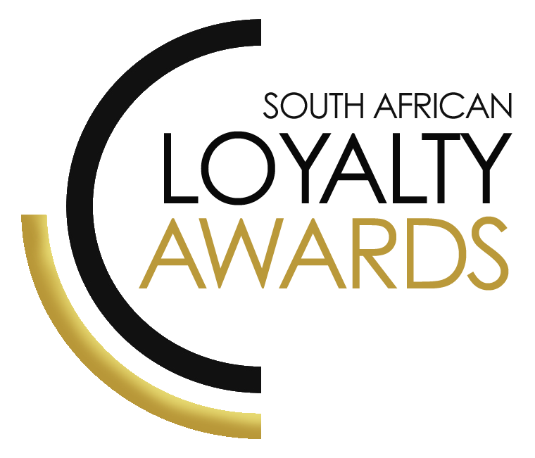
CATEGORY 21
BEST USE OF MULTI-CHANNEL LOYALTY COMMUNICATION / ENGAGEMENT INCLUDING
SOCIAL MEDIA
2023
ENTRY FORM

ENTRY CONTACT INFORMATION:
Company name:
Contact name:
Job title:
Business email:
Telephone number:
Company logo: Transparent background (must be attached to your email as a separate file)
Permission to enter the Loyalty Awards:
(Signature)
Signed by:
(Name & Surname)
Role:
Date:
DECLARATION:

I hereby declare that all evidence submitted as part of this awards entry, is 100% factual and further evidence can be requested by the judges should more clarity be required.
I understand that falsely provided information will lead to disqualification, at the discretion of the judging panel.

Signature: _______________________________________________

I have read the small print

Signature: _______________________________________________

I give permission for the submitted logo and winning paragraph to be used in the awards announcement and website, should this entry receive recognition.

Signature: ________________________________________________

SUMMARY:
This award will be awarded to recognise engagement/communication innovation across multiple channels. The brand must show insight-led use of email, mobile & social within a loyalty initiative which delivers loyalty & CRM communications to the brand’s membership base.
Please ensure your entries address the below criteria:
- ROI/ increased revenues/profits
- Connect with consumers on all of their favourite channels
- Increase consumer engagement and conversion rates
- Increase your customer base, lower customer acquisition costs
What we require:
- Entry contact information
- Signed declaration and permission
- Transparent logo
- Winning paragraph
- 1 page executive summary
- Submission (max 4 pages) – all boxes completed
- Supporting evidence files (max 5 items)
Entry fees:
A fee of R1 950 (ex VAT) is charged per category entry. Once you have submitted your entry, an invoice will be emailed to you. All entry fees must be paid in full before 14 June 2023. Unfortunately, no refunds can be processed once entries are submitted.
All entries must be emailed to: info@southafricanloyaltyawards.com
Should your file sizes be too big for email, please share via dropbox or wetransfer.
AGENCY SUBMISSIONS (On behalf of clients)
If you are an agency and entering the awards on behalf of your client, you will need permission and sign-off from your client to enter their details for the awards. We require the signed agreement to accompany your entry. Please download the agency agreement here. Please note: We will not review your entry if we have not received a signature from your client.
WINNING PARAGRAPH (max 150 words):

(To be published should your entry receive recognition – permission must be granted in the declaration on page 2)

EXECUTIVE SUMMARY:

ENGAGEMENT INITIATIVE DESCRIPTION:

THE NEXT 3 PAGES MUST HIGHLIGHT THE ACHIEVEMENTS IN THE FOLLOWING DELIVERABLES:

- ROI/ increased revenues/profits
- Connect with consumers on all of their favourite channels
- Increase consumer engagement and conversion rates
- Increase your customer base, lower customer acquisition costs

1. ROI/ increased revenues/profits:

2. Connect with consumers on all of their favourite channels:

3. Increase consumer engagement and conversion rates:

4. Increase your customer base, lower customer acquisition costs:

SAVING CRITERIA:
Once the above entry information has been completed, your files and supporting documentation must be saved in the following format when submitting your entry please:
file name = category#-programmename-brandname.doc
e.g. CATEGORY1-ROYALREWARDS-ROYALHOTEL.doc
Once you have saved all your files in the correct format, simply enter by emailing: info@southafricanloyaltyawards.com

If your file sizes are too big, simply send it to us via dropbox or wetransfer.
CONFIDENTIALITY:
To view our confidentiality agreement that has been signed by all judges and South African Loyalty Awards employees, please click here.
HAVE ANY QUESTIONS?
Please call us on 021 715 8619 or email info@southafricanloyaltyawards.com and we will gladly assist!

