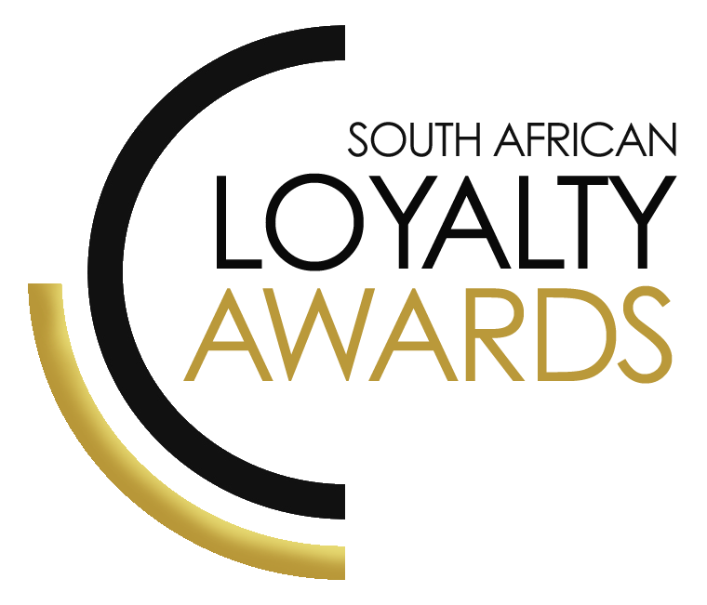

**CATEGORY 11**

**PROGRAMME WITH THE BIGGEST IMPACT ON THE BEHAVIOUR**

**OF SOUTH AFRICANS  
  
ENTRY FORM**

**ENTRY CONTACT INFORMATION:**

|  |  |
| --- | --- |
| **Company name:** |  |
| **Contact name:** |  |
| **Job title:** |  |
| **Business email:** |  |
| **Telephone number:** |  |
| **Company logo: Transparent background (must be attached to your email as a separate file)** |  |
|  | |
| **Permission to enter the Loyalty Awards:  (Signature)** |  |
| **Signed by: (Name & Surname)** |  |
| **Role:** |  |
| **Date:** |  |

**DECLARATION:**

|  |
| --- |
| I hereby declare that all evidence submitted as part of this awards entry, is 100% factual and further evidence can be requested by the judges should more clarity be required.  I understand that falsely provided information will lead to disqualification, at the discretion of the judging panel.  Signature: _______________________________________________  I have read the [small print](https://truthza-my.sharepoint.com/personal/rowen_truth_co_za/Documents/SALA/THE%20SMALL%20PRINT%202023%20SALA.pdf)  Signature: _______________________________________________  I give permission for the submitted logo and winning paragraph to be used in the awards announcement and website, should this entry receive recognition.  Signature: ________________________________________________ |

**SUMMARY:**

This award will be awarded to the brand which demonstrates that it has had the biggest impact on its customers’ behaviour in its industry over time, (>12 months) and can demonstrate how it has significantly impacted its sector.

**Please ensure your entries address the below criteria:**

1. Behaviour changes in your customer base
2. How behaviour changes in your members has resulted in positive commercial results
3. Significant impact on your sector
4. Innovation

**What we require:**

* Entry contact information
* Signed declaration and permission
* Transparent logo
* Winning paragraph
* 1 page executive summary
* Submission (max 4 pages) – all boxes completed
* Supporting evidence files (max 5 items)

**Entry fees:**A fee of R1 950 (ex VAT) is charged per category entry. Once you have submitted your entry, an invoice will be emailed to you. All entry fees must be paid in full before 14 June 2023. Unfortunately, no refunds can be processed once entries are submitted.  
  
**All entries must be emailed to: info@southafricanloyaltyawards.com**Should your file sizes be too big for email, please share via dropbox or wetransfer**.  
  
AGENCY SUBMISSIONS (On behalf of clients)**

If you are an agency and entering the awards on behalf of your client, you will need permission and sign-off from your client to enter their details for the awards. We require the signed agreement to accompany your entry. Please download the agency agreement [**here.**](https://truthza-my.sharepoint.com/personal/rowen_truth_co_za/Documents/SALA/Agency%20agreement%202023.pdf) **Please note:** We will not review your entry if we have not received a signature from your client.

**WINNING PARAGRAPH (max 150 words):**

|  |
| --- |
| (To be published should your entry receive recognition – permission must be granted in the declaration on page 2) |

**EXECUTIVE SUMMARY:**

|  |
| --- |
|  |

**THE NEXT 4 PAGES MUST HIGHLIGHT THE ACHIEVEMENTS IN THE FOLLOWING DELIVERABLES:**



1. Behaviour changes in your customer base (KPIs)
2. How behaviour changes in your members has resulted in positive commercial results
3. Significant impact on your sector
4. Innovation

|  |  |  |  |  |  |  |  |  |  |  |  |  |  |  |  |  |  |  |
| --- | --- | --- | --- | --- | --- | --- | --- | --- | --- | --- | --- | --- | --- | --- | --- | --- | --- | --- |
| **1****. Behaviour changes in your customer base:** List the key KPIs where your programme clearly shows a behaviour change of members vs non-members.   |  |  |  | | --- | --- | --- | | These KPI boxes **MUST** be completed with your submission | | | | **Behaviour change** | **Member** | **Non-member** | | 1. |  |  | | 2. |  |  | | 3. |  |  | | 4. |  |  | |

|  |
| --- |
| **2. Show how behaviour changes in your members resulted in positive commercial results**  We wish to see how the programme has changed the lives of South Africans.  All of these values should be stated over a 12 month period. |
| |  |  | | --- | --- | | **Behaviour change** | **Commercial impact over 12 months** | | 1. |  | | 2. |  | | 3. |  | | 4. |  | |

|  |
| --- |
| **3. Significant impact on your sector**  (e.g. show how your programme has either created, grown or improved your industry sector.) |
|  |

|  |
| --- |
| **4. Innovation**  (e.g. please showcase how your programme has implemented “never been seen before” innovations to drive customer behavioural change.) |
|  |

**SAVING CRITERIA:**

Once the above entry information has been completed, your files and supporting documentation must be saved in the following format when submitting your entry please:  
  
**file name** = category#-programmename-brandname.doc  
e.g. CATEGORY1-ROYALREWARDS-ROYALHOTEL.doc  
  
Once you have saved all your files in the correct format, simply enter by emailing: [info@southafricanloyaltyawards.com](mailto:info@loyaltyawardssouthafrica.com)

If your file sizes are too big, simply send it to us via dropbox or wetransfer.

**CONFIDENTIALITY:**

To view our confidentiality agreement that has been signed by all judges and South African Loyalty Awards employees, please [**click here**](https://truthza-my.sharepoint.com/personal/rowen_truth_co_za/Documents/SALA/JUDGES%20CODE%20OF%20CONDUCT%20FOR%20SOUTH%20AFRICA%20LOYALTY%20AWARDS%202023.pdf)**.** It is critical to submit as much information as possible, knowing that it is covered by this confidentiality agreement.

**HAVE ANY QUESTIONS?**

Please call us on **021 715 8619** or email [info@southafricanloyaltyawards.com](mailto:info@loyaltyawardssouthafrica.com) and we will gladly assist!