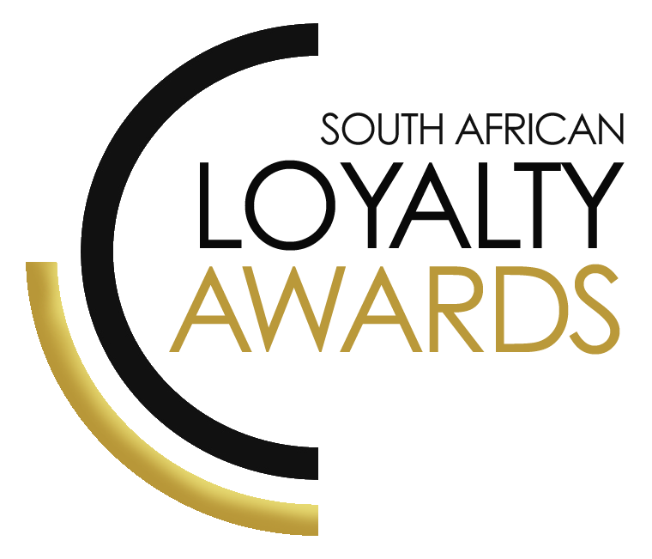
CATEGORY 17
BEST LOYALTY AGENCY
(MARKETING / REWARDS)
OF THE YEAR
ENTRY FORM

ENTRY CONTACT INFORMATION:

Company name:
Contact name:
Job title:
Business email:
Telephone number:
Company logo: Transparent background (must be attached to your email as a separate file)
Permission to enter the Loyalty Awards:
(Signature)
Signed by:
(Name & Surname)
Role:
Date:

DECLARATION:

I hereby declare that all evidence submitted as part of this awards entry, is 100% factual and further evidence can be requested by the judges should more clarity be required.
I understand that falsely provided information will lead to disqualification, at the discretion of the judging panel.

Signature: _______________________________________________

I have read the small print.

Signature: _______________________________________________

I give permission for the submitted logo and winning paragraph to be used in the awards announcement and website, should this entry receive recognition.

Signature: ________________________________________________

SUMMARY:
This award will be awarded to the best loyalty (marketing & rewards) agency in South Africa. Agencies are encouraged to submit their achievements in loyalty and CRM and for brands they have worked with in this environment. A demonstration of skills in loyalty marketing, CRM and rewards fulfilment to drive programme performance will be assessed.
Please ensure your entries address the below criteria:
- Strategic understanding of loyalty & CRM
- Campaign effectiveness and/or rewards fulfilment campaigns due to agency
- Use of customer segmentation analytics
- Ability to drive programme performance improvements
What we require:
- Entry contact information
- Signed declaration and permission
- Transparent logo
- Winning paragraph
- 1 page executive summary
- Submission (max 4 pages) – all boxes completed
- Supporting evidence files (max 5 items)
Entry fees:
A fee is charged per category entry. Once you have submitted your entry, an invoice will be emailed to you. All entry fees must be paid in full before the date stipulated in the small print. Unfortunately, no refunds can be processed once entries are submitted.
All entries must be emailed to: info@southafricanloyaltyawards.com
Should your file sizes be too big for email, please share via dropbox or wetransfer.
AGENCY SUBMISSIONS (On behalf of clients)
If you are an agency and entering the awards on behalf of your client, you will need permission and sign-off from your client to enter their details for the awards. We require the signed agreement to accompany your entry. Please note: We will not review your entry if we have not received a signature from your client.

WINNING PARAGRAPH (max 150 words):

(To be published should your entry receive recognition – permission must be granted in the declaration on page 2)

EXECUTIVE SUMMARY:

THE NEXT 3 PAGES MUST HIGHLIGHT THE ACHIEVEMENTS IN THE FOLLOWING DELIVERABLES:

- Strategic understanding of loyalty & CRM
- Campaign effectiveness and/or rewards fulfilment campaigns due to agency
- Use of customer segmentation analytics
- Ability to drive programme performance improvements

1. Strategic understanding of loyalty & CRM:

2. Campaign effectiveness and/or rewards fulfilment campaigns due to agency:

3. Use of customer segmentation analytics:

4. Ability to drive programme performance improvements (please include measurable results):

SAVING CRITERIA:
Once the above entry information has been completed, your files and supporting documentation must be saved in the following format when submitting your entry please:
file name = category#-programmename-brandname.doc
e.g. CATEGORY1-ROYALREWARDS-ROYALHOTEL.doc
Once you have saved all your files in the correct format, simply enter by emailing: info@southafricanloyaltyawards.com

If your file sizes are too big, simply send it to us via dropbox or wetransfer.
CONFIDENTIALITY:
To view our confidentiality agreement that has been signed by all judges and South African Loyalty Awards employees, please click here.
HAVE ANY QUESTIONS?
Please call us on 021 715 8619 or email info@southafricanloyaltyawards.com and we will gladly assist!

