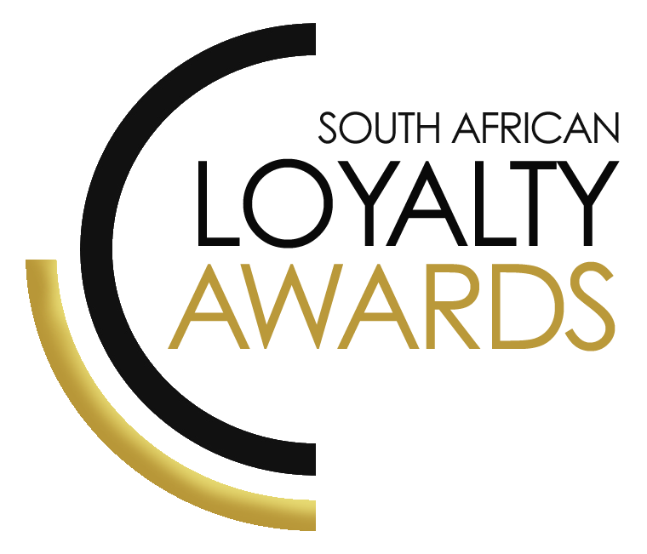
CATEGORY 26
INDUSTRY TEAM
OF THE YEAR
2023
NOMINATION FORM

ENTRY CONTACT INFORMATION:

Contact name:
Company name:
Job title:
Nominated by:
(Name & Surname)
Signed by:
Role:
Date:
Business email:
Telephone number:

DECLARATION:

I hereby declare that all evidence submitted as part of this awards entry, is 100% factual and further evidence can be requested by the judges should more clarity be required.
I understand that falsely provided information will lead to disqualification, at the discretion of the judging panel.

Signature: _______________________________________________

I have read the small print

Signature: _______________________________________________

I give permission for the winning paragraph to be used in the awards announcement and website, should this entry receive recognition.

Signature: ________________________________________________

SUMMARY:

We would like to recognise teams who are making a significant contribution to the loyalty industry. There are no set criteria for this award/recognition, but we must see service to the loyalty industry above and beyond normal job functions.
What we require:
- Entry contact information
- Signed declaration and permission
- Winning paragraph
- Reasons for nomination
- Supporting evidence files (max 5 items)
Entry fees:
None.

All entries must be emailed to info@southafricanloyaltyawards.com
Should your files be too big to email, please share via dropbox or wetransfer.

WINNING PARAGRAPH (max 150 words):

(To be published should your entry receive recognition – permission must be granted in the declaration on page 2)

NOMINATED TEAM: ______________________________
COMPANY: ___________________________________________

REASONS FOR NOMINATION
R

SAVING CRITERIA:
Once the above entry information has been completed, your files and supporting documentation must be saved in the following format when submitting your entry please:
file name = category#-programmename-brandname.doc
e.g. CATEGORY1-ROYALREWARDS-ROYALHOTEL.doc
Once you have saved all your files in the correct format, simply enter by emailing: info@southafricanloyaltyawards.com

If your file sizes are too big, simply send it to us via dropbox or wetransfer.
CONFIDENTIALITY:
To view our confidentiality agreement that has been signed by all judges and South African Loyalty Awards employees, please click here.
HAVE ANY QUESTIONS?
Please call us on 021 715 8619 or email info@southafricanloyaltyawards.com and we will gladly assist!

